

**NCO & Non-NCO**

**Marine Security Guard (MSG) School**

**Reporting Requirements / Helpful Hints**

**MCESG Contact Information**

|  |  |
| --- | --- |
| **MCESG Screening Team** | (571) 243-2194 MCESG-rast@groups.state.gov |
| **MCESG Medical Chief** | (703) 784-3558/(703) 432-6694 |
| **MCESG Overseas Medical Screener** | (703) 784-1549 |
| **MCESG DMO Representative** | (703) 432-0630/(703)784-2831 |
| **MCESG Security** | (703) 784-4843 MCESG_Headquarters_Security_Section@usmc.mil |
| **MCESG Passport Section** | (703) 784-4795 / 571-234-3913 Ashlea.d.tran@usmc.mil |

**\*\*\*If any changes to your status occur, (alcohol related issues, finances, speeding/parking tickets, family issues, etc.) no matter how small, contact the MCESG Screening Team immediately\*\*\***

**Transportation options to MSG School**

-Flying

* Fly into either Dulles International Airport (IAD) or Regan International Airport (DCA) and then use a taxi to get to MSG School. Ensure your driver can enter a DoD installation, not all drivers have access to military installations (save all receipts for travel claim).

*\*DO NOT fly into Baltimore –Washington International Airport (BWI), it’s too far away from MSG School*

*\*DO NOT use your GTCC to purchase flights. Use the Line of Accounting (LOA) code on your orders.*

-~~POV~~

* This option is ONLY available for student Detachment Commanders. Sgts and below are **NOT** authorized to bring any vehicle to MSG School.

-Other

* Friends/Family may drop you off at MSG School.

**Directions for Reporting-in**

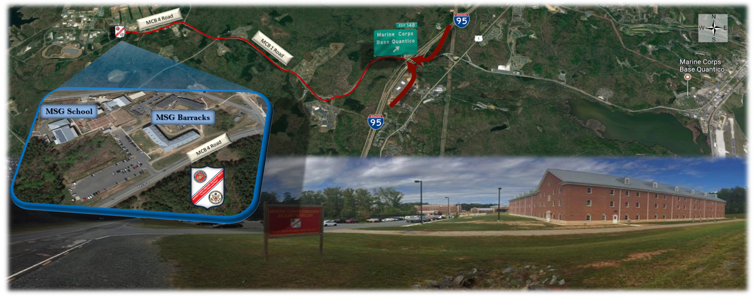

*IMPORTANT* When in transit to the MSG School from the airport, please ensure the individual driving or taxi driver has the appropriate qualification to enter MCB Quantico. Each driver is required to have a certificate from the PMO Visitor's Center. Without this certificate the driver will not be authorized on base and you will be dropped off at the gate. If this happens, please call another ride share or taxi service in the area with the proper authorization.

- You can navigate to MSG school using google maps “Marine Corps Embassy Security Group”

- North to South on I-95

* Use exit 148 and then turn right.
* Go through the base gate which is guarded by the sentry
* Stay straight all the way to MSG School (do not make any turns until you see the above red sign)

- South to North on I-95

* Use exit 148 and then turn left.
* Go through the base gate which is guarded by the sentry
* Stay straight all the way to MSG School (do not make any turns until you see the above red sign)

**Arriving at MSG School Barracks**

*Students are not authorized to arrive any earlier than two days prior to their MSG School date.

* Annual leave should be taken prior to checking into MSG School.

*\*There is no opportunity to take leave in between graduation and reporting to your first post.*

* Wear proper civilian attire when arriving to the MSG School barracks.

*Once you arrive, the barracks DNCO will give further instruction as to when you will put on your Service Alpha uniform and stand a formal check-in with an Instructor Advisor from the MSG School; typically, this is the Sunday prior to the first day of school and times will vary throughout the day (proper uniform fit and USMC grooming standards are expected).

* Check-in with the DNCO at the MSG School barracks, building #27276 and phone # (703) 432-7058 (red brick building pictured above)

*DNCO will endorse orders and hand you your preassigned room key.

**Administrative Requirements**

**Checklist for reporting to MSG School DNCO:**

*\*You must report to MSG School within Marine Corps Height and Weight Standards. Mustaches are not authorized while on the MSG Program.*

*\*Every student (Detachment Commander & Watch Stander) receives a meal card while at MSG School.*

*\*prior to reporting in, your orders will be used for chow*

* + Original Orders (Signed)

*\* Bring three copies of your orders.*

* PCS TEMINS—All Marines who do not rate BAH; the majority of Marines will have these types of orders.

*You will completely detach from your unit prior to checking into MSG School.

* TAD—Only those students who rate Basic Allowance for Housing (BAH) will travel to MSG School with these orders; very few will receive these orders.

*Marine will need to print out their DTS Authorization (DD Form 1610). The printed-out DD Form 1610 will be stamped by the DNCO upon Check-In.

*You will not detach from your parent unit prior to attending MSG School. You will return to your parent unit once you graduate from MSG School and then you will coordinate DMO to pack you out, detach from your parent unit, and then report to your first detachment post.

*L*og onto MCTIMS to generate Funding letter (search under Student Registrar, enter “Marine Security Guard” in the search box, click on your class date, find your name, click the drop box to the left of your name and select “Generate Funding Letter”).*

*Develop DTS orders using Funding letter.

*\*You must have physical copies(x3) of your Original Orders, Itinerary, receipts, and web orders upon check-in to the MSG School barracks DNCO.*

*\*If you have any questions about DMO, call MCESG DMO at (703) 432-0630.*

* Completed (signed) Commanding Officers Recertification & Financial Checklist (AKA Phase IV)

\**complete a PFT recertification 45 days prior to reporting in.*

* Medical/Dental Records.
* Completed (signed) overseas medical screening forms (AKA Phase III)
* Service Record Book (if not already electronically scanned in system).
* Current LES / BIR / BTR, Record of Service (MOL copy is acceptable, not older than 30 days).
* $500 of accessible money in your bank accounts (you do not need to bring cash).
* Must have a Check Book/Checking Account (some countries do not have ATMs).
* Fitness Report occasion for MSG School (E-5 only)
  + If you have PCS TEMINS orders use (TR) as the occasion.
  + If you have TAD orders use (TD) as the occasion.
* Uniform/Clothing Packing List
* All required issued uniforms per MCBUL 10120 FY_ Minimum Clothing Allowance (to include the All-weather coat and Wooly Pully sweater with epaulet)

*\*All uniforms must be serviceable and fit properly.*

*\*You will stand a wall locker and uniform inspection*

* Proper civilian PT gear (AKA Rainbow Gear)
* Green on Green PT gear (Running shoes, MC Running Suit, sweat top/bottoms, glow belt, etc.)
* Civilian clothing (Bring a weekend’s worth of proper civilian attire).
* Business suits & Civilian style luggage (Optional)

*You will be given an allowance to purchase suits and luggage while at MSG School.

*\*Double breasted and eccentric colored suits are not authorized on the MSG program*

*For Security reasons, sea bags, camouflage style backpacks/bags, etc. are not authorized for use while you travel to post

* Passports

*\*Start this process immediately after receiving your Welcome Aboard email if you are a Detachment Commander\**

*See Passport PowerPoint on One Drive*

* DMO
* You are required to bring all uniform items annotated in the current McBul 10120; DO NOT put them in DMO.
* POV Options
  + Sell it
  + Leave it with family or friends (Special Power of Attorney)

\**Once you receive official orders to your first post, you may have your family or friends store your vehicle, with the Special Power of Attorney, at a vehicle storage facility using the Line of Accounting (LOA) code found on your orders. Call DMO at (703) 432-0630 or (703) 432-2831 for detailed information.*

* Pets
  + You are NOT authorized to bring pets on this program; only DetCmdrs have this option.
* MCESG Security

*\*Start this process immediately after receiving your Welcome Aboard email*

* Call MSG Security Office at (703) 784-4843 or email MCESG_Headquarters_Security_Section@usmc.mil to begin the process for obtaining a Top Secret Security Clearance—electronic Questionnaire for Security Processing (eQIP). Please ensure you have the following information when contacting the security office: Assigned Class/EDIPI/DOB/Email POC

*\*Failure to contact the security office before your school date may result in your security clearance being delayed and not processed for submission to the Office of Personnel Management (OPM).*

*\*It is essential you complete your eQIP before departing your unit.*

*\*Your unit’s S-2 shop is not involved with any portion of this process. Do NOT call the MCESG S2 with questions regarding clearance information.*

* (30 days prior) Begin ISOPREP with your unit’s S3, seeking out your PRMS Manager. ISOPREPs may be completed on NIPR computers using the below website.

*(https://prmsglobal.prms.af.mil/prmsconv/profile/survey/survey.aspx)

* Fingerprints will be electronically processed at MSG School

*\*Do not bring fingerprint cards to MSG School.*

* Medical Requirements

*\*Bring your orders and/or your completed RELM to all medical appointments to verify the need for you to receive the specific screenings.* *Overseas screening must be completed within 90 days of your school report date; ensure you keep a copy for MSG School.*

* (90 days prior) Overseas screening for MSG students consists of the following forms:
  + **DD2807-1** (Mar 2015)
  + **DD2808** (Oct 2005)
  + **NAVMED 1300/1** (Rev. 1-2016).
  + **NAVPERS 1300/16 (**Rev. 11-09)

*\*Bring your orders to all medical appointments to verify the need for you to receive the specific screenings*

* (90 days prior) Other Medical:
* G-6-PD and sickle cell testing is documented in medical record
* Audiogram is completed 6 months prior to school
* PPD test within 4 months prior to reporting
* Blood Type and DNA test completed
* Immunizations up to date (Typhoid(every 2 years), Tetanus, Hepatitis A, Hepatitis B or Twinrix completed, IPV, Yellow fever(every 10 years), Documented MMR and Varicella or positive titer
* Complete a full optometry, overseas screening physical (Austere Posting), PDHRA.
* (90 days prior) Female specific (21 years of age & older) – if medical is refusing to a give you a well women’s (pap/pelvic) exam, contact the MSG HM1 at (703) 784-3558.
* (45 days prior) Recertification Signatures

*Completed within 45 days prior to your school date. You will only get one signature from the Overseas Screener who will look over your entire medical package and ensure everything you previously had signed (from the 90 day mark) is still accurate. The Overseas Screener is only located at a Military Treatment Facility (MTF); you must go to your nearest MTF for this signature. The below website will help you locate a MTF:

<https://hnfs.com/apps/tsclocator/default.aspx>

* + The Overseas Screener will recertify all of the below with their signature:
    - Medical
    - Dental (Class 1; nothing less)
    - Optometry (full eye exam with dilatation)

*\* No eye surgery within 6 months of reporting in.*

*\*Medical, Dental and Optometry will not be available in all MSG Post assignments.*

* Required PME prior to attending MSG School (based on your current grade)
* Leading Marines Distance Education Program (EPME3000AA)
* Corporal’s Course Distance Education Program (EPME4000AA)
* Sergeant’s Course Distance Education Program (EPME5000AA)

*\*Reference MARADMIN 663/16 for guidance on attending Resident PME in regards to SDA duties.*

* Other Marine Net courses to complete

Complete all courses found on the MarineNet website located under: *Catalog>>Self paced courses>>Marine Security Guard (MSG) School* . The Marine will then select their respective position as either a *Watchstander* or a *Detachment Commander*.

* Required Annual training requirements:
* Rifle Range
* Gas Chamber
* CFT/PFT
* Semi Annual Height and Weight

**\*\*\*If any changes to your status occur (legal issues, alcohol related, finances, speeding tickets, family issues or anything that could prevent you from leaving the country, etc.) no matter how small, contact the MCESG Screening Team immediately\*\*\***